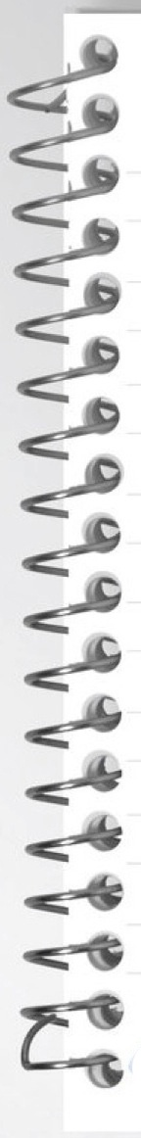

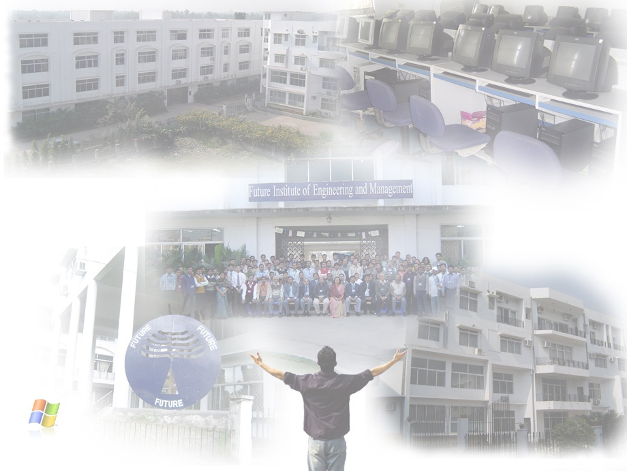

**Data Structure and Algorithm Lab (C) - PCC-CS391**

**REPORT ON:** …………………………..………………………………………………………………Lab.

**SAPTARSHI CHAKRABORTY**

**NAME:** …………………………………………………………………………………………………………..

**COMPUTER SCIENCE & ENGINEERING**

**DEPARTMENT:** ……………………………………………………………………………………………..

**3RD**

**22/CSE/068**

**CSE-II**

**C**

**ROLL NO: .**……………..….…… **SEM:** …….…….… **GRP:** ….…… **SECTION:** ……..........

**1, 2 , 3**

**II**

**ASSIGNMENT NO:** ………..……**PROGRAM NO:** …..………………………………………....



**TITLE / OBJECTIVE:**

**IMPLEMENTATION OF STACK DATA STRUCTURE WITH ARRAY, USER DEFINED STRUCTURE & STRUCTURE POINTER.**

**UNDERSTANDING STACK OPERATIONS :**

1. **Pop , 2. Push , 3. Peek , 4. Display**

.…………………………………………………..…………………………………..................................

……….………………………………………………………………………………..................................

………….……………………………………………………………………………..................................

………….……………………………………………………………………………..................................

………….……………………………………………………………………….…….................................



……….………………………………………………………………………………..................................

………….……………………………………………………………………………..................................

………….……………………………………………………………………………..................................



**14/09/2023**

**05/10/2023**

**PERFORMANCE DATE:** …....……………….. **SUBMISSION DATE:** ………………….......

**EXAMINER’S SIGNATURE:** ……………………………………………………………………………..